EC2 Auto Scaling

Creating a launch template

When you create an Auto Scaling Group, you must specify a Launch Template. The first step in this lab is to create the Launch Template for an EC2 Auto Scaling Group.

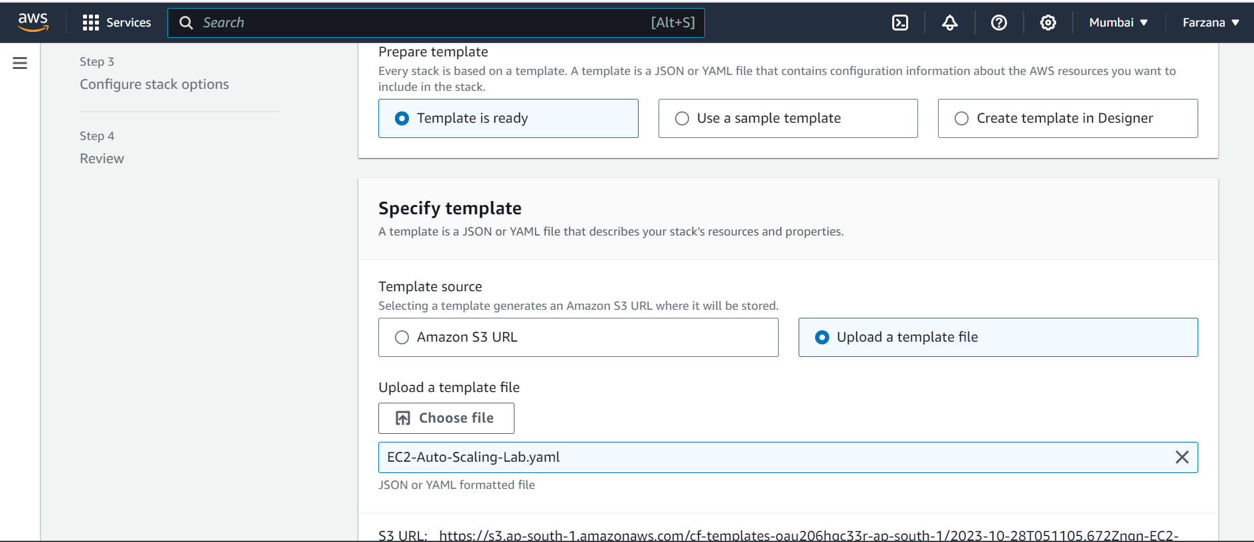

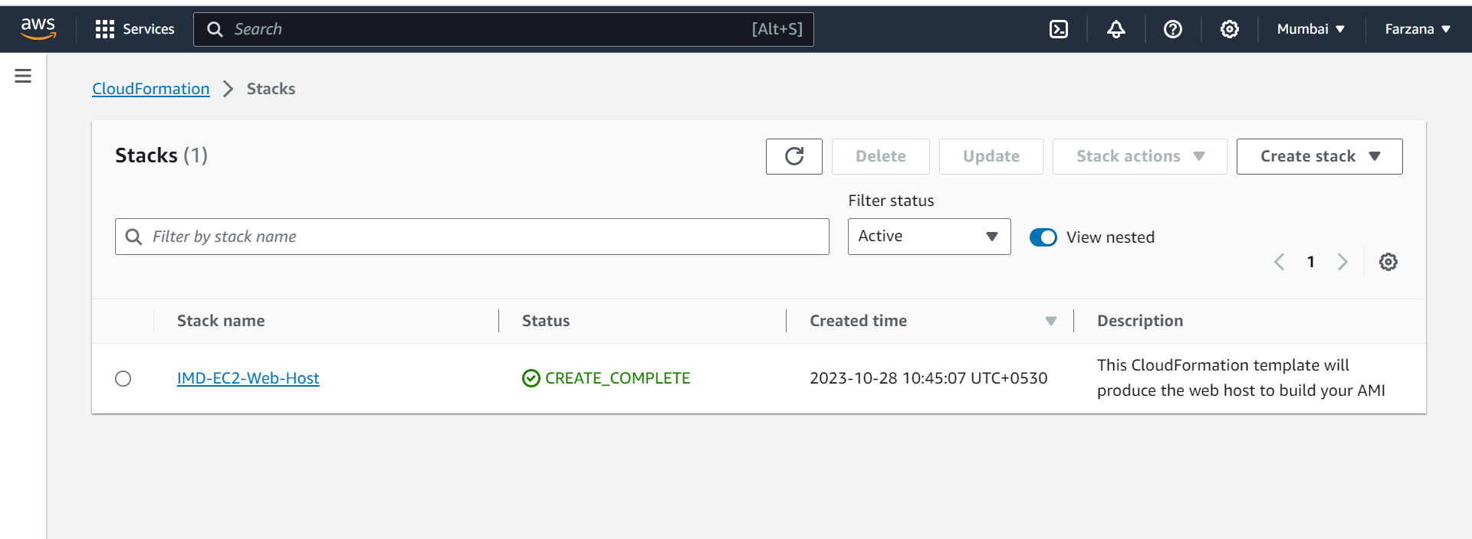

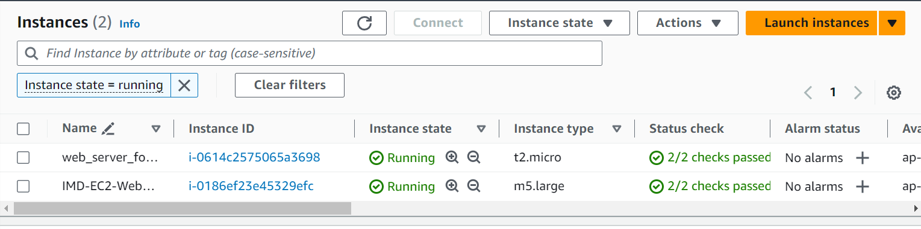

Generate a custom AMI of the web server created in the EC2 – Linux lab:

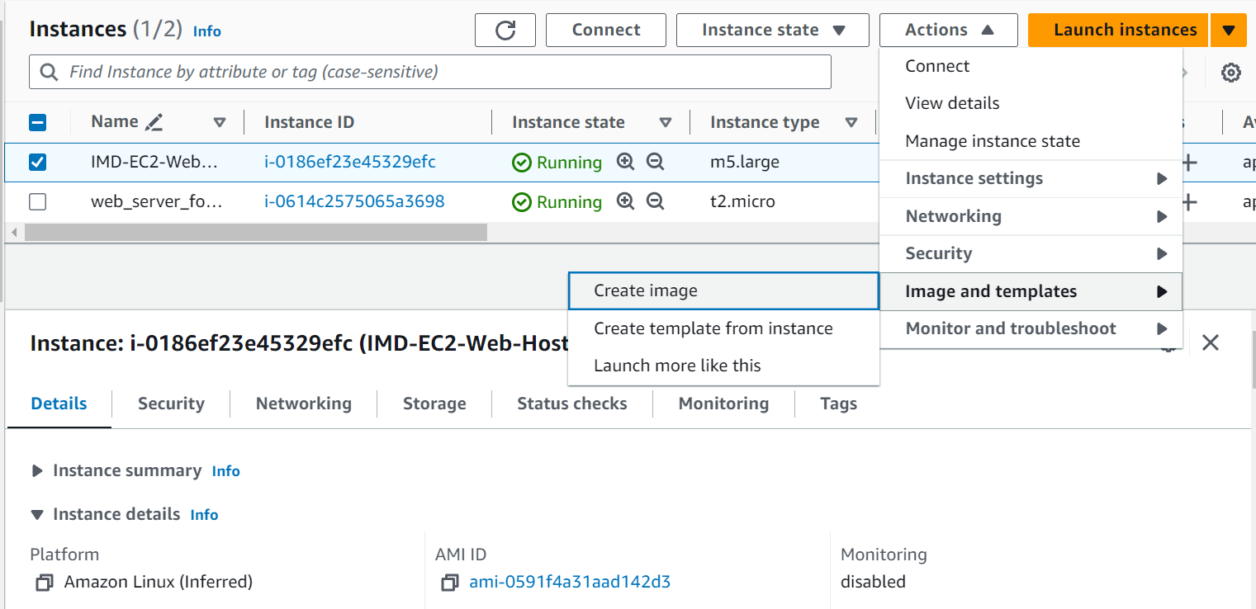

Creating a new security group for auto scaling group

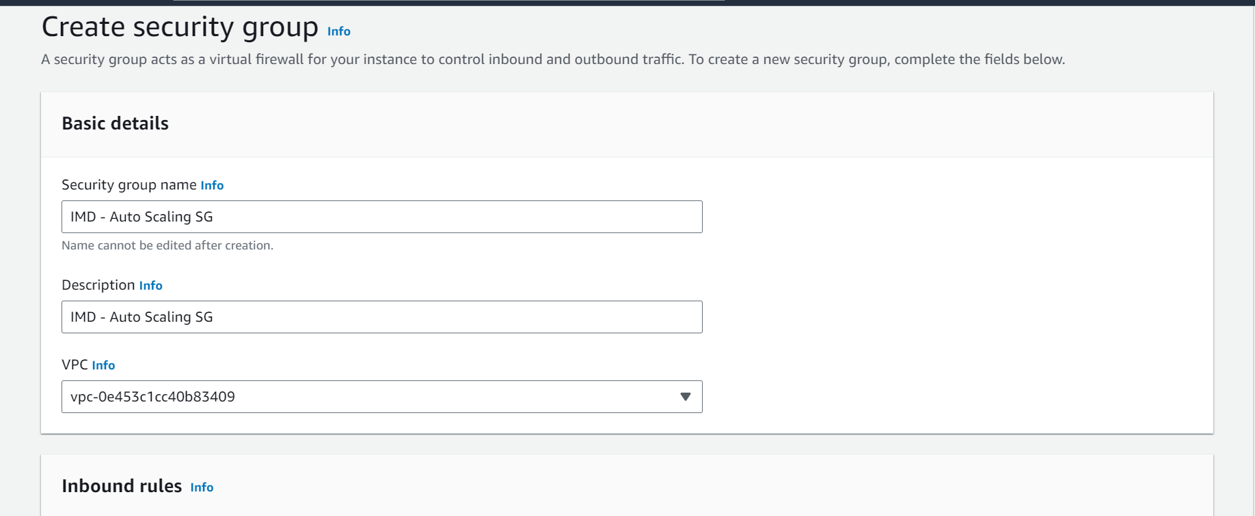

**Launch template name and description.**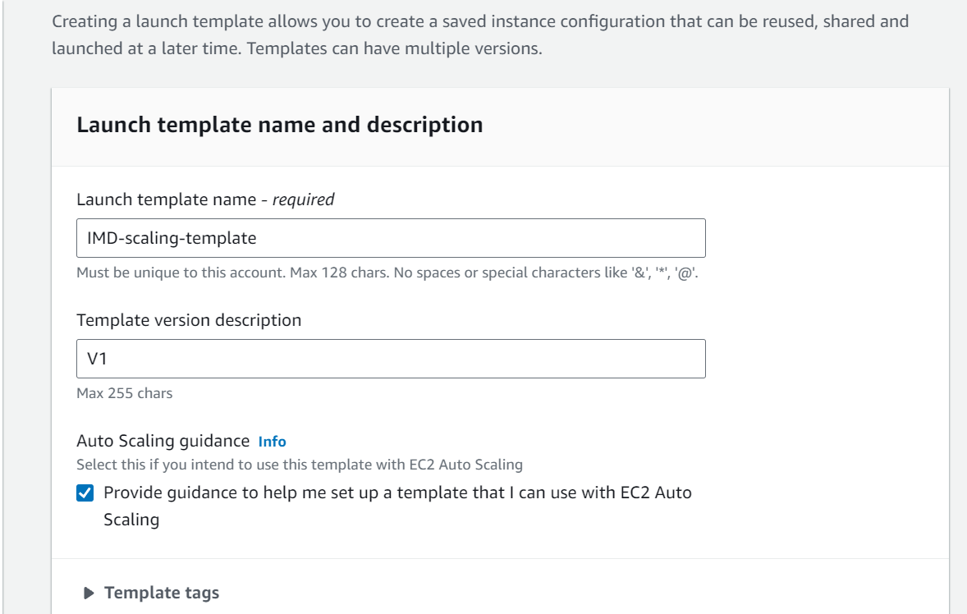

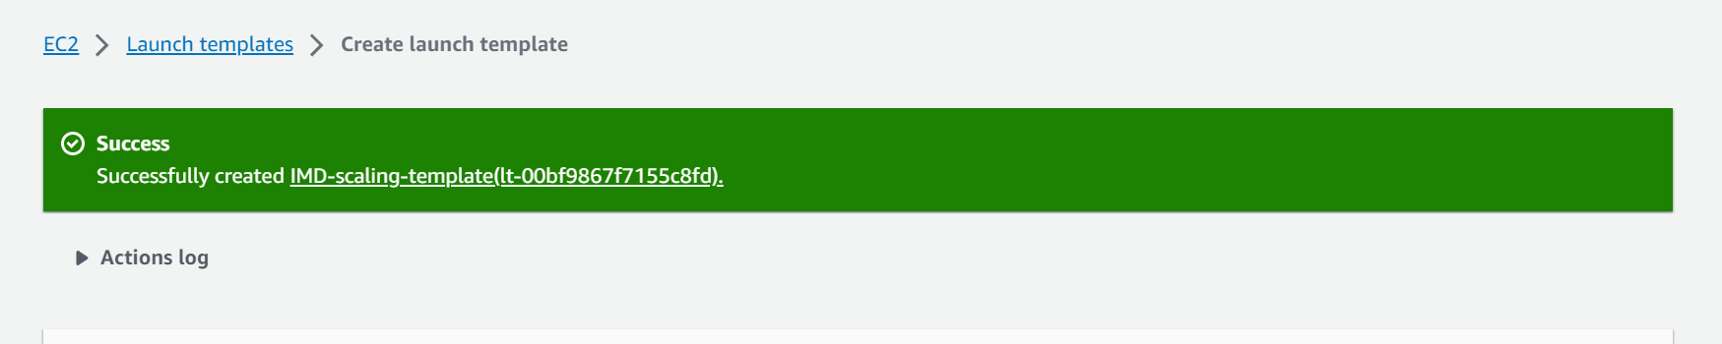

# Setup an Auto Scaling Group

Create auto scaling group

# 

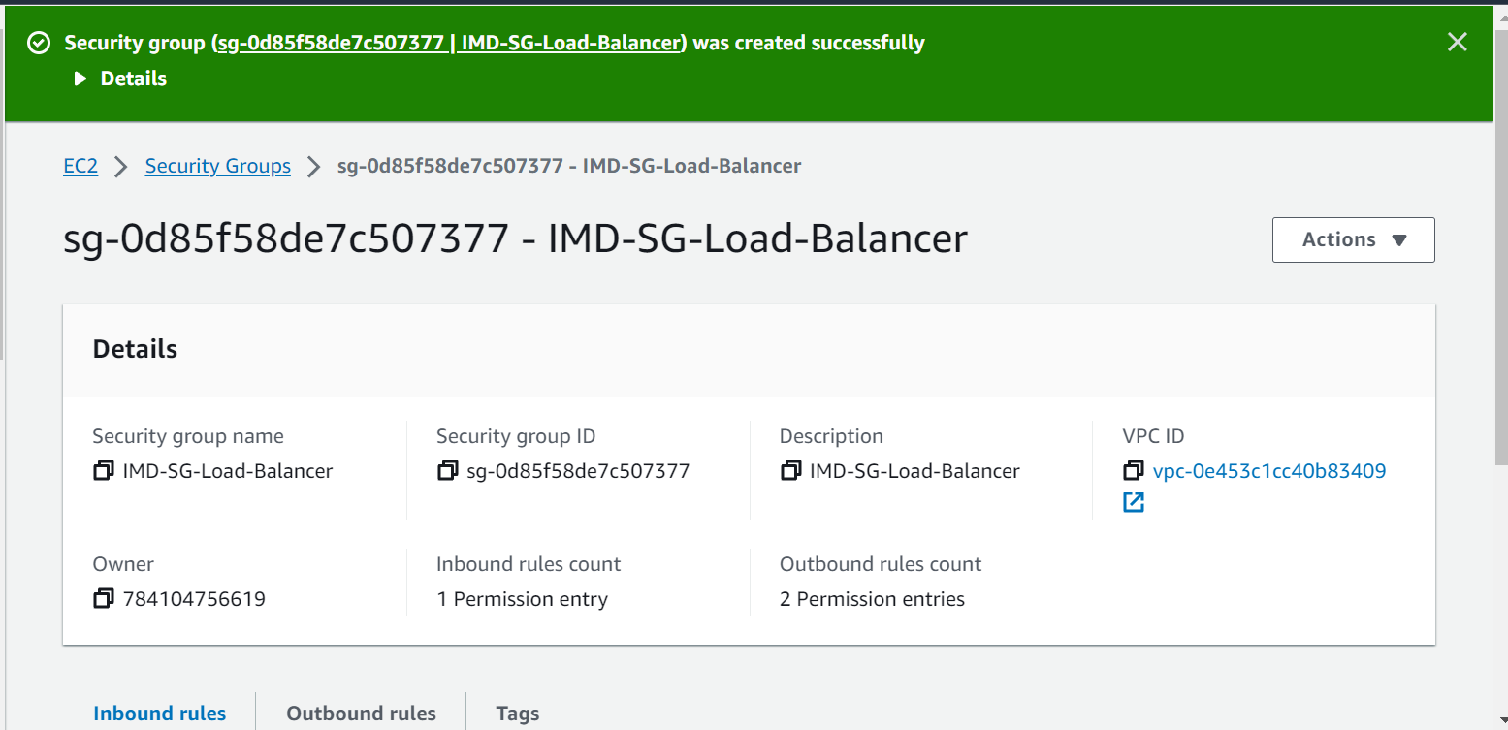

We will now test to make sure your load balancer is working. There is currently only one instance (or target) running in the auto scaling group, but you should be able to access the website.

Return to your the load balancers page by selecting **Load Balancers** from the left hand menu. Under the "Description" tab **copy** the DNS name and **paste** it into a web browser. You should now see the website being loaded from your auto scaling group. Leave this page open, you will need it in the next step.

